View from Munich Olympic Tower to Grossglockner:
Impact of Refraction Thomas May, Oct. 2007

The impact of atmospheric Refraction on panoramic views is small. It can be estimated with help of two summits which are nearly in a line. One summit should be far away and the other closer and nearly covering the second one.
A good example is the view from Munich Olympic Tower (705m) towards Grossglockner (3798m), the highest mountain in Eastern Alps, 150km away.
Grossglockner is nearly completely hidden behind Hochsalwand, 1625m high and 63 km away. There are rare days during the year, when Grossglockner can be seen. I took photos on 25th Nov 2006 and 15th Dec 2006. Their quality is limited, but Grossglockner can be distinguished.

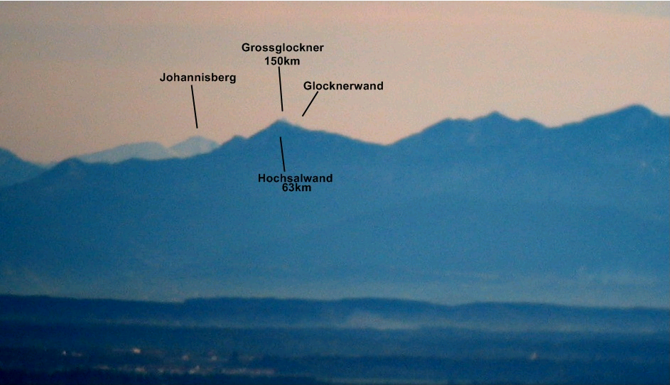
Grossglockner seen from Munich Olympic Tower, 25th November 2006

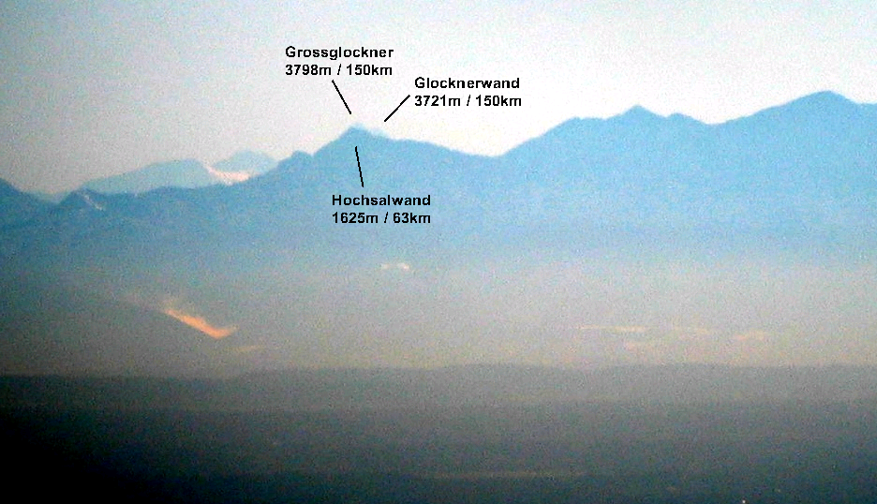
Grossglockner seen from Munich Olympic Tower, 15th December 2006

Grossglockner Summit is geometrically invisble from Munich Olympic Tower

The drop of height of a mountain caused by earth curvature can be approached by:

0.0785 [m/km^2] d^2

d is the distance from the viewpoint in kilometers
0.0785 is derived from 1 / 2R
R is the Radius of the Earth (6371km)
This approximation is quite accurate for distances smaller than 500km.

For example if a mountain is 100km away, it seems to be 785m lower.
Grossglockner is 150km away, so it seems to be 1766m lower.
Hochsalwand is 63km away, so it seems to be 311m lower.

The tower platform is 705m high,
so Grossglockner is then relatively 3798m – 1766m – 705m = 1327m high
and Hochsalwand 1625m – 311m – 705 m = 609m.
You can calculate from this, that Grossglockner Summit misses about 120 meters to be seen behind Hochsalwand. Grossglockner appears with angle 0.507° and Hochsalwand with 0.554°. So Grossglockner should be geometrically invisible.

Jonathan de Ferranti’s Approximation for Refraction Effect

In order to reflect the impact of Refraction, Jonathan de Ferranti http://www.viewfinderpanoramas.org uses a modified formula for the drop in height:

0.0655 [m/km^2] d^2 (= 0.1695 [m/mi^2] d^2)

which corresponds to an effective Earth Radius of 7640km ( 4750 mi)
So we see less drop in height compared to the purely geometrical effect above.
Refraction makes distant mountains seem a bit higher.

With Refraction taken into account, we get:
Grossglockner is 150km away, so it seems to be 1474m lower.
Hochsalwand is 63km away, so it seems to be 260m lower.

The tower platform is 705m high, so Grossglockner is relatively 1619m high and Hochsalwand 660m. The 2 summits appear with angles 0.618° and 0.600°.
You can calculate from this, that Grossglockner summit raises about 50 meters above Hochsalwand. So it is highered 170 meters above Hochsalwand caused by Refraction.

Here is the calculated shape with this approximation:

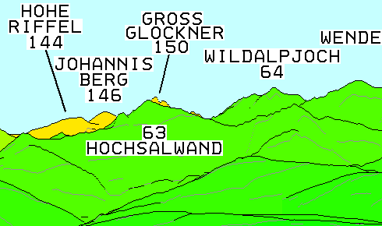

Observation of Grossglockner on 25th Nov 2006 and 15th Dec 2007

25th November 2006 in Munich was a day with strong dry and warm „Föhn“ wind.
The photos were taken taken at 3pm, when the temperature reached 15°C, which is rather mild for this season. The photo below shows the impression of this Föhn day and the location of Grossglockner.

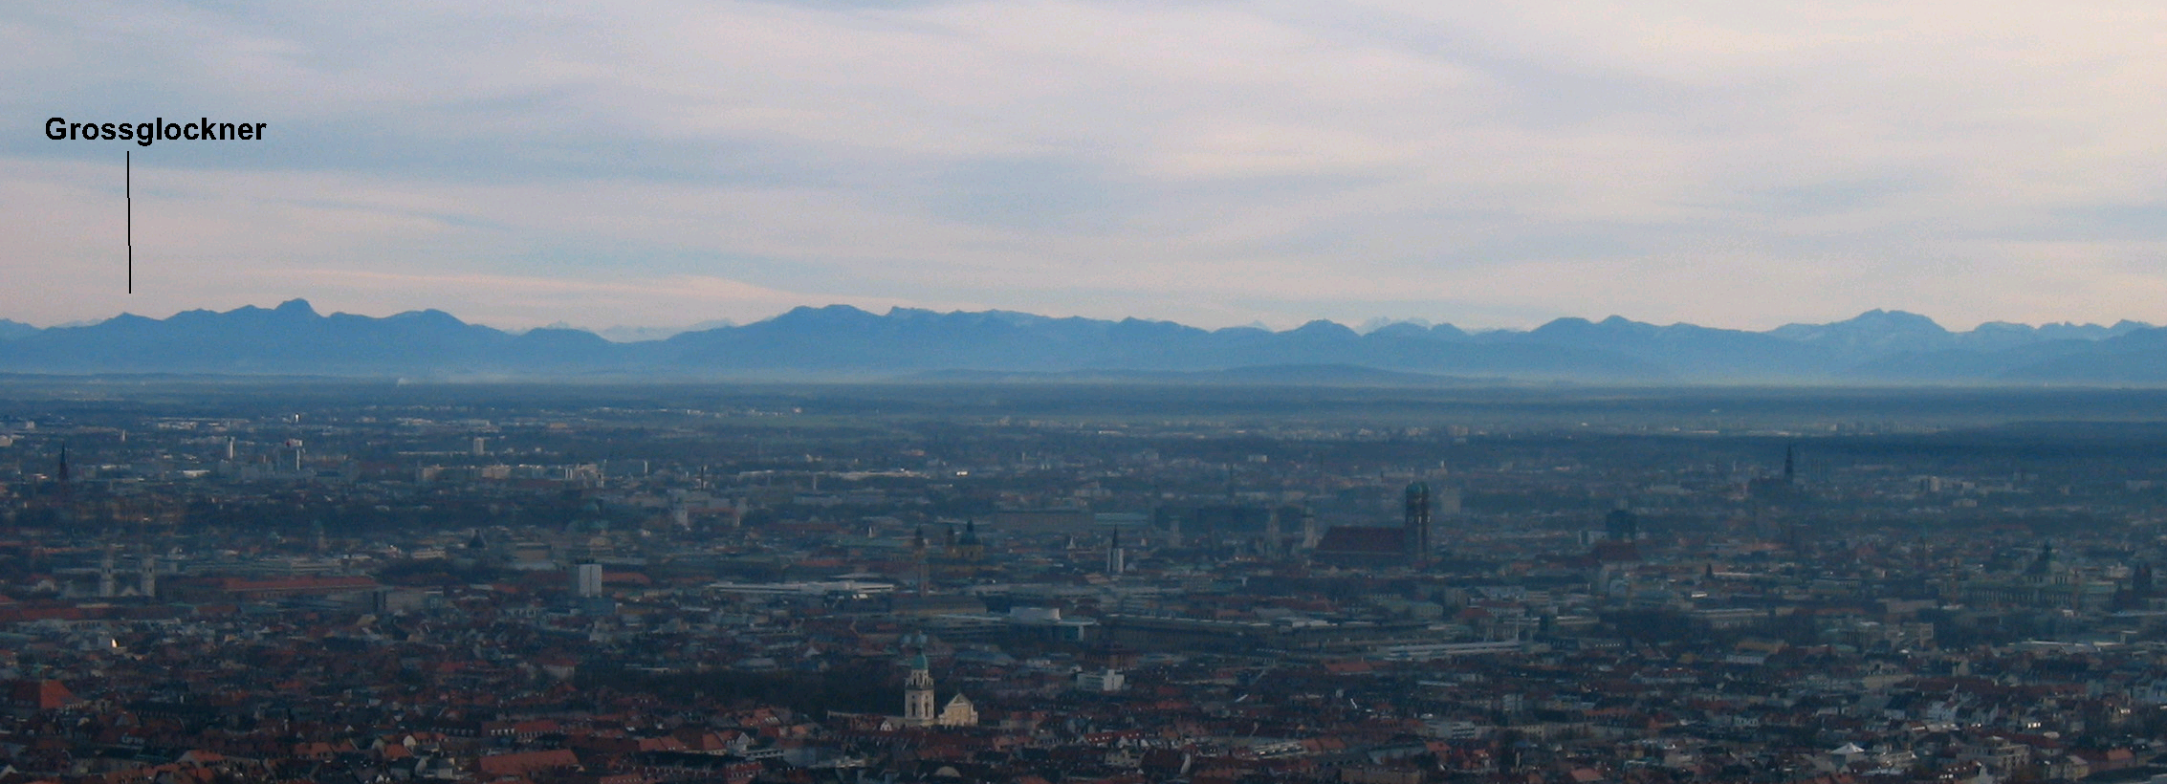

On 15th December 2006, we had a completely different weather situation: High pressure, sunshine and nearly no wind. The photo was taken at 11am. The temperatur mimimum in Munich on ground level was –1°C in the morning and reached 12°C in the afternoon.
On the Wendelstein (1840m) the temperature was already at 7°C in the morning, so we faced a Temperature Inversion. The Inversion layer was maybe at 900m, so the view from the tower to the Alps goes through the Inversion layer. The photo below shows well the Inversion with dry air in altitude and humid and cool air below.

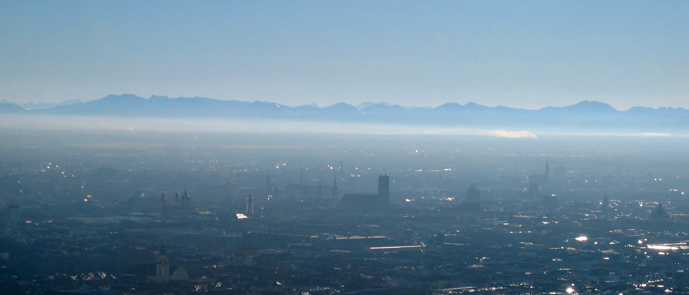

View from Olympic Tower towards the Alps on 15th Dec 2006, 11am.

Results for Refraction Effect, extracted from the photos

From the photos of Grossglockner I extracted the following approximate values:

On 25th Nov. 2006 Grossglockner raised about 30 meters above Hochsalwand.
I have roughly estimated this with help of side summit Glocknerwand (3721m).
So it was highered 150 meters above Hochsalwand caused by Refraction.
This corresponds to a drop of
0.0668 [m/km^2] d^2 (= 0.1729 [m/mi^2] d^2)
which corresponds to an effective Earth Radius of 7485km ( 4652 mi)

On 15th Dec. 2006 Grossglockner raised about 70 meters above Hochsalwand.
So it was highered 190 meters above Hochsalwand caused by Refraction.
The corresponds to a drop of
0.0638 [m/km^2] d^2 (= 0.1652 [m/mi^2] d^2)
which corresponds to an effective Earth Radius of 7837km ( 4870 mi)

This is illustrated in below photo:

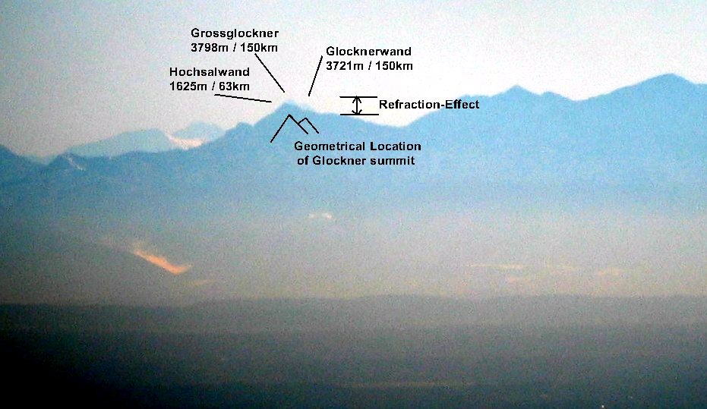

Summary of Results and Comparison with Classical Gaussian Refraction Value 0.13

My photo on a Föhn day shows the Grossglockner to rise 30m behind Hochsalwand, which is 150m more than without Refraction Effect.On a day with Temperature Inversion Grossglockner rises about 70m behind Hochsalwand, which is 190m more than without Refraction Effect. These are rough estimations limited by photo quality.
Jonathan de Ferranti predicts the Grossglockner to rise 50m behind Hochsalwand, which is 170m more than without Refraction Effect. This is in rather good coincidence.

Results:

Drop of height of a mountain: Effective Radius Glockner / Hochsalwand

Purely Geometrical: 0.0785 [m/km^2] d^2 6371 km -120 m
Ferranti (with Refraction) 0.0655 [m/km^2] d^2 7640 km + 50 m
Day with Föhnwind 0.0668 [m/km^2] d^2 7485 km + 30 m
Day with Inversion 0.0638 [m/km^2] d^2 7837 km + 70 m

Total Effect for Grossglockner (3798m) at distance 150km, including the percentage of Refraction compared to Earth Curvature:

Gain in Height by Refraction: Refraction Angle: Percentage:

Ferranti 0.0130 [m/km^2] d^2 +293m +0.11° 6.7’ 17% = 0.17
Day with Föhnwind 0.0117 [m/km^2] d^2 +263m +0.10° 6.0’ 15% = 0.15
Day with Inversion 0.0147 [m/km^2] d^2 +331m +0.13° 7.6’ 19% = 0.19

The Refraction Angle is the angle between the geometrical and the observed line of sight.
So Grossglockner appears roughly 260 -330 meters higher than it is, which corresponds to an Refraction Angle of 0.10° - 0.13°.

This shows that Jonathan de Ferranti’s approximation for Refraction is good and accurate even for various meteorological situations. It also shows that Inversion tends to increase the effect of Refraction.The classical value for Refraction 0.13, derived by Gauss, is clearly to low on both observation days.

